
EYFS News
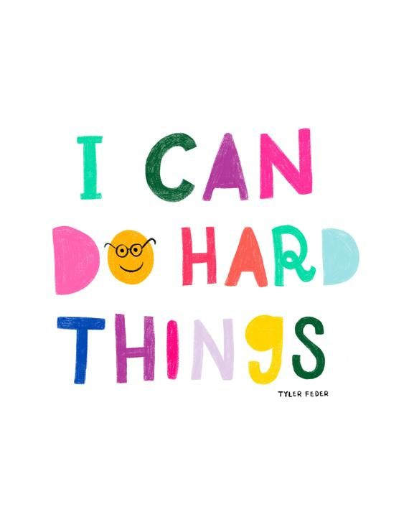


Key Dates
- 6th June-Carnival

- 19th June-Summer Fair

Remember, no child is the same…however my door is always open if you have any queries or concerns :)

As part of our topic this half term we will be getting chicks again and are very much looking forward to learning about life cycles and having fluffy cuddles.
Welcome back :)
I hope everyone had a lovely Easter break.
It was lovely to see and hear the children excitedly catching up with their classmates and sharing their holiday adventures.
It’s been lovely to welcome our new Nursery starters also, who have settled in well.

Reception Homework Ideas
- Read, read, read
- Phonics home learning letters
- Practice letter formation
- Writing shopping lists- sounding out
- Bingo-numerals and quantities 10-20
- Letter formation practice
- Learn tricky words-play teachers
- Use scissors-on leaves/playdough/paper
- Add and subtract within 10/20

Don’t forget…
- Reception reading records are checked M/W/F. Sometimes your child will come home with a new book on these days, other times we will encourage them to read the book again, this is to ensure children develop fluency.
- Forest Fridays=waterproof coat with hood and gloves/sunhat etc. and named wellies (kept in school).
- Our class library session will be Friday. Children will bring home a ‘reading for pleasure’ book, to be shared at home with friends and family alike.
- PE will Friday PM therefore no PE kit is required as children will be in forest school clothing.
- £1 snack money per week, or in advance, whichever is preferred. Summer term is 6 and 8 weeks so £14 snack in total, for those whose children are full time and not in receipt of pupil premium. (If you’re unsure please just ask)

What will we be learning?
Our focus topic for the first half term is ‘Animal Safari, where will be building on last terms knowledge of farm animals, learning about different types of animals such as birds, mammals and reptiles.
In the second half term we will learn about the plants and animals that live at the seaside, in our topic ‘On the Beach’. As well as looking at holidays and the importance of keeping safe in the Sun.

