

Church Lane,
New Mills,
High Peak.
SK22 4NP
01663 743222

29/1/26




St George’s C of E Primary School
info@st-georgescofe.derbyshire.sch.uk www.st-georgescofe.co.uk

Dear Parents/Carers,
Happy New Year! The Christmas holiday feels like a long time ago as we have had a busy and productive beginning to 2026. There is news to celebrate and plans for this term to be shared:

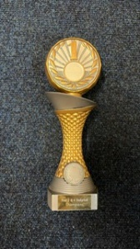
The Y3/4 Dodgeball Team
We are incredibly proud of our Y3/4 dodgeball team who took part in the area sports event on 14th January and came 1st! Their teamwork and great sportsmanship shone and everyone had a fabulous time. CONGRATULATIONS!

The Year of Reading 2026

We have launched The Year of Reading with a fun book tasting café event. During this, the tables were set with books and pupils are invited to taste and try reading new genres. The genres included: newspapers, magazines, emotional stories, wordless stories and nature non-fiction. This took place in our fabulous library area.

The next event is National Storytelling Week, 2-8 February. You are welcome to join your child’s class for story time on Monday 2nd February at 2:45-3:15pm. During the rest of the week, you are invited to pop into school to read or share a favourite children’s book with your child’s class. Please speak to the class teacher to arrange this.

Extra-Curricular Music at St George’s

We are so happy to welcome our new music teacher, Carolyn Woodham, to St George’s. Children can learn the piano, flute or bassoon in private lessons during the school day. If you are interested in your child taking up this opportunity please ask at the office for a letter. Violin lessons are also available from Catherine Porter. There is a relaxing singing club on Tuesday lunch time also. Music in our school is very important as it builds emotional intelligence while helping students connect with others.
Clubs
Clubs are a fabulous way for our pupils to try new things in a relaxed social event. Please check out the club timetable on the school website in order to encourage your child to learn a new skill and have some fun. https://www.st-georgescofe.co.uk/useful-links/

Children’s Mental Health Week 9-15th February
Mental Health Week this year has the theme ‘This is my Place’. During Children’s Mental Health Week, we’ll be talking about how we can help everyone feel like they belong. We will share our special places so we can learn from each other what makes us feel happy. We’ll learn how to be kind, include others, and make sure no one feels left out. Because everyone deserves to feel like they have a place where they are accepted, cared for, and loved.
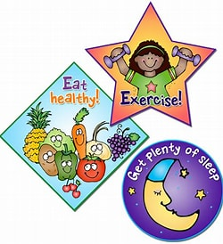
The Health Champions 2026
We have a very keen new team of Year 5 Health Champions in school who have been involved in with the local schools’ hub. They will share what they have learned and follow up with healthy activities for the whole school. Well done Health Champions and thank you for representing our school so well.
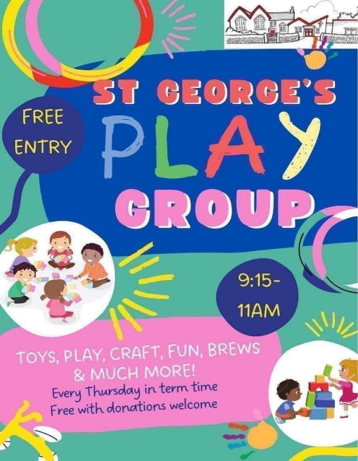
Playgroup
We are delighted that our fabulous playgroup is up and running for 2026! Each Thursday in term time from 9:15-11 am there are toys, games, brews and fun for free! Please bring your friends too.

Dates for your diary:
- Thursday 29th January, playgroup begins
- 2nd February, 2:45-3:15pm story time in classrooms
- 2-8th February, National Storytelling Week
- 9-13th February, Young Person’s Mental Health Week
- 12th February, Y5/6 trip to Jodrell Bank
- 12th February, Disco 3:15-4:30pm
- 13th February, own clothes day- £1 for New Mills Football Club
- 13th February, end of half term
- 23rd February, return to school and Y3/4 FIRST SWIM
- 5th March, World Book Day! Stay posted for more information of plans
- 2/3-4/3/26- Parents’ evening
- 27/3/26 -Finish for Easter
- 13/4/26 Start back summer term 1
- 1/5/26- Y3/4 trip to Manchester Museum
- 11/5/26-14/5/26 year 6 SATs
- 18/5/26-22/5/26 year 2 SATs
- 22/5/26 Finish summer term 1
- 1/6/26 Start back summer term 2
- 6/6/26 New Mills Carnival
- Multiplication check year 4 -taken during the first 2 weeks of this term
- 8/6/26 year 1 phonics & year 2 resits
- 26/6/26 & 29/6/26 Inset days
- 23/7/26 Finish for Summer

If you have concerns or questions, please don’t hesitate to contact us.

Best wishes,

Sarah Craig- Executive Headteacher
Fiona Hall- Head of School

