Welcome to Y3/4!
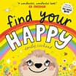
Dear children and families,
Thank you for a fabulous moving up morning yesterday! We did some fun games, activities and listened to a story. This is a little letter with some key things to help you feel confident about becoming Year 3 in September. Don’t worry, you will be great!
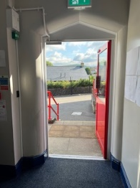
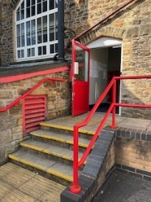
After lining up in the morning, we walk down to the red door and come in through there with our teacher. At home time we will walk up to the top yard together and wait with our teacher to find our families and be picked up.
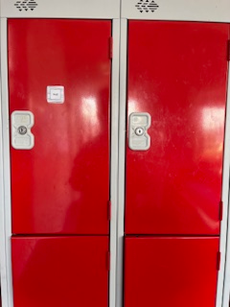
We have lockers outside the classroom for all our things. Look for your name and put your bag and coat in the locker.

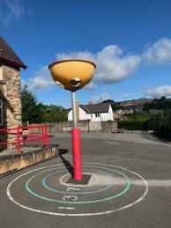
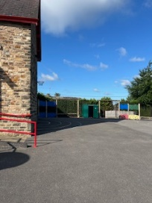

Your playtimes will be on the KS2 playground.

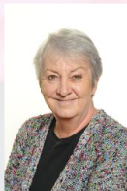



Your teachers will be:

Mrs. Hall Mrs. Calvert Miss Andrews Mrs. Swindells
We are really looking forward to teaching you!
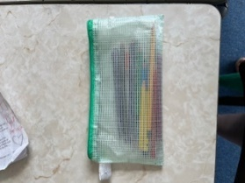
In class you will not need any of your own pens and pencils as we have school pencil cases and lots of lovely, coloured felts and pencils.

At play time you can bring your own healthy snack, as we do not have fruit provided like KS1 do. Please do not bring chocolate, sweets or crisps. We recommend fruit, raisins, cheese, rice cakes, crackers and flap jacks. Also, please bring a water bottle every day.


After the first day back in school in September, we will have a new reading book. Please bring it to school every day and write in the diary when you have read at home.

If you have any questions please feel welcome to email us. Further information about PE and topics will come home in September.
Mrs Calvert’s email address:
vickyc123@st-georgescofe.derbyshire.sch.uk
Mrs Hall’s email address:
fionah17@st-georgescofe.derbyshire.sch.uk

