
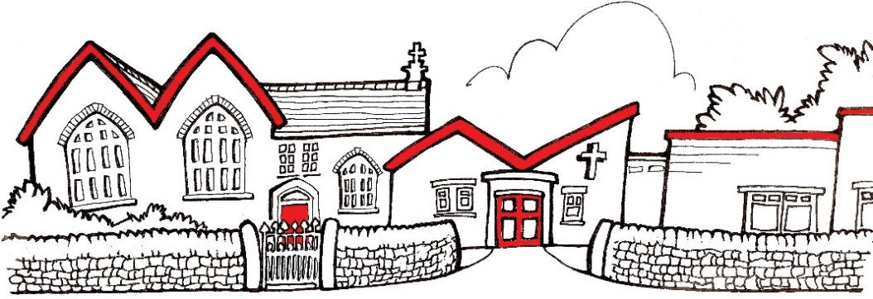
Church Lane,
New Mills,
High Peak.
SK22 4NP
01663 743222

St George’s C of E Primary School
info@st-georgescofe.derbyshire.sch.uk www.st-georgescofe.co.uk

Mrs. S Craig Mrs. J Rackstraw
Exec Headteacher Chair of Governors

Dear Parents / Carers,

We are delighted to announce that we are planning a school trip for Y3/4 to the Grosvenor Museum in Chester on Tuesday 15th July 2025. They will be experiencing an amazing day of Roman history, including hands-on sessions in the museum and a guided Roman soldier walk.

We expect to leave school at approximately 8:45am and arrive back to school at approximately 3:15pm. Please arrive on time as we will be leaving promptly.

The whole trip including the coach will cost £30 per child, this can be paid via Parent Pay, in three payments of £10 to break up the cost. If we receive insufficient voluntary contributions the trip may have to be cancelled. However, if you are experiencing financial difficulty and are unable to afford this trip, please speak to Mrs Morley in the office.

The children will need a packed lunch (including a drink) on the day (no glass bottles and healthy options please). If your child is entitled to a free school meal we can provide them with a free packed lunch, please indicate on the form if your child would like one. The students will have to carry their bag for the day so please send their lunch in as small a bag as possible.

Your child will need to wear their school uniform and bring a waterproof coat. Sensible walking shoes will be needed as they will be walking through Chester with their Roman centurion. Your child will NOT need to bring any spending money.

If you would like your child to take part in this trip, please fill out the form below and return it to school as soon as possible. Payment for the trip must be made by .

Kind Regards,
Mrs. Hall, Mrs. Redfearn and Mrs. Craig

I would like my child ……………………………………………………… to take part in the trip to Chester on Tuesday 15th July 2025.

Signed………………………………………………………………………………………………………………parent / carer

My child is entitled to free school meals and would like a free school packed lunch on this day. (please tick box).

I will make my payment on Parent Pay by .

