Autumn 1 |  | Autumn 2
Project | Companion Project | Project | Companion Project
Me and My Community | Exploring Autumn | Once Upon a Time | Sparkle and Shine
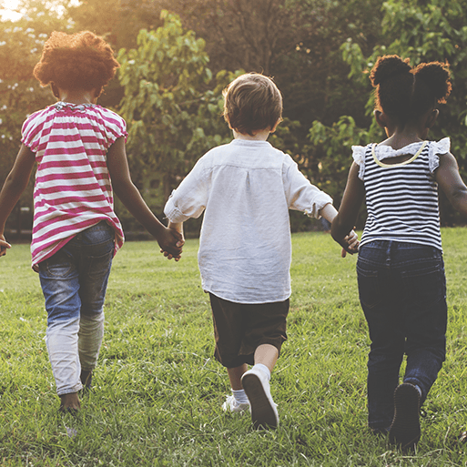This project supports children with settling into the new rules and routines of school and encourages them to make new friends and feel confident in their class. It teaches children about being helpful, kind and thoughtful at home and at school. This project also teaches children how they are unique and special, the importance of friendship and how people in their family, school and local community are important and can help them. | 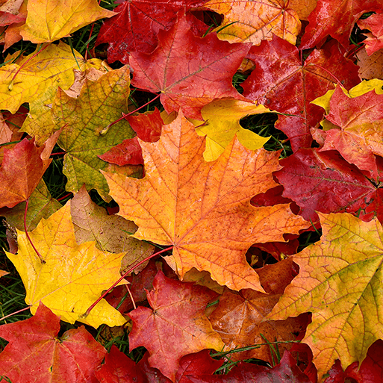This project teaches children about the natural changes that happen during the season of autumn, including how the weather changes, why trees lose their leaves and how wild animals prepare for winter. |   In the Once Upon a Time project, your child will be introduced to the wonderful world of stories. It encourages children to learn, retell and act out familiar and traditional tales. They will also listen to alternative contemporary stories to see different viewpoints from the characters. They will also make up their own stories and make masks, props and puppets to act out their stories. |   In the Sparkle and Shine project, your child will explore different celebrations that take place in autumn and winter, focusing on the significance and symbolism of light at this time of year. They will take part in a variety of creative activities and discover more about how Christmas, Diwali and Hanukkah are celebrated around the world.
Cycle B; What are we learning about?

Spring 1 |  | Spring 2
Project | Companion Project | Project | Companion Project
Starry Night | Winter Wonderland | Dangerous Dinosaurs | Puddles and Rainbows
This project explores the differences in the world at night compared to during the day. It teaches children about the importance of a good night’s sleep and helps them to discover what is happening in the world while they are sleeping, including finding out about nocturnal animals. | 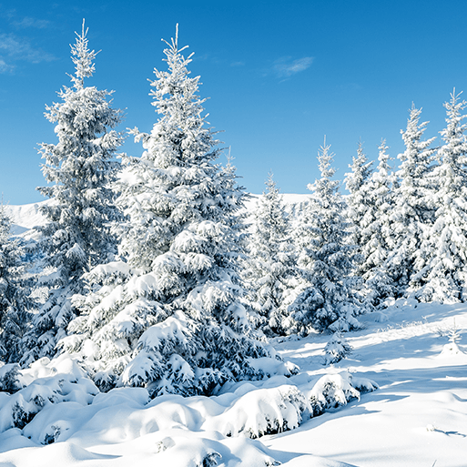This project teaches children about the changes that happen during winter, including the types of weather associated with winter. It also explores places that have snow all year round and the types of animals that live there. |   This exciting project teaches children about the different animals that roamed Earth millions of years ago and how they are related to animals that live on Earth today. | 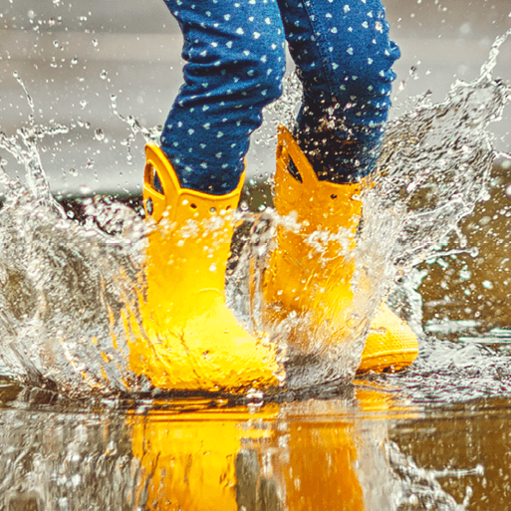  This mini project teaches children about the weather that happens during spring and allows them to explore natural phenomena, including rainbows. It supports them to explore colour in the natural world.

Summer 1 |  | Summer 2
Project | Companion Project | Project | Companion Project
Sunshine and Sunflowers | Shadows and Reflections | Big Wide World | Splash
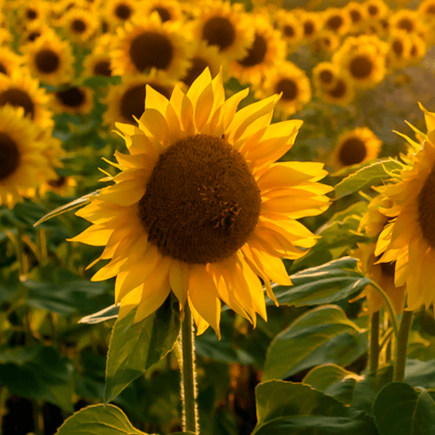  In the Sunshine and Sunflowers project your child will explore their local environment and see how it has changed throughout the year. They will grow flowers, fruit and vegetables in the garden area. They will learn how to care for plants and animals, identifying some different types. They will take part in outdoor learning activities and find out how to stay safe in the sun. |   This project teaches children about natural phenomena, including shadows, reflections and echoes. They explore how shadows are formed and how they can change. |   In the Big Wide World project, your child will find out about the world in which they live. They will learn about different climates and explore habitats, including their flora and fauna. They will locate the United Kingdom on a world map and compare life in the United Kingdom with life elsewhere. They will also learn about caring for their environment, both locally and beyond. | 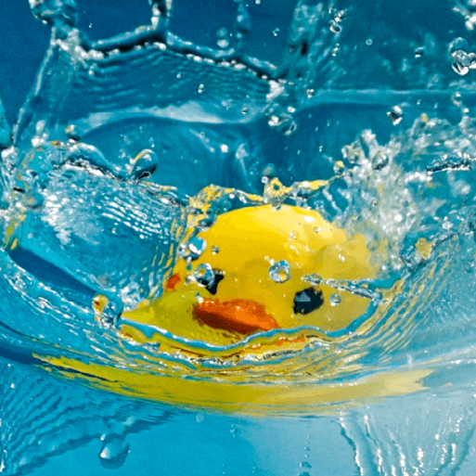  This project teaches children about water, including floating and sinking, freezing and melting, and why it is important for living things to stay hydrated.

