Autumn 1 |  | Autumn 2
Project | Companion Project | Project | Companion Project
Let’s Explore | Build It Up | Marvellous Machines | Puppets and Pop Ups
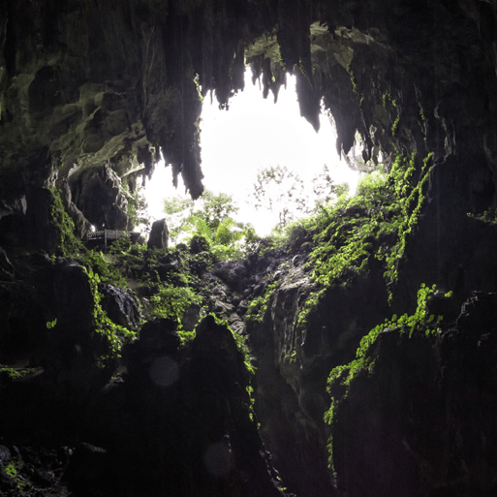This project teaches children about the environments that they share with others, including their homes, school and places in the local community. Your child will explore their class environment and school grounds so that they feel settled and happy in their new surroundings. They will learn about the local environment and find out about places they have visited on holiday. They will look at and create maps for journeys. | This project teaches children about structures and materials and gives them the opportunity to work in groups to create collaborative structures. |   In the Marvellous Machines project, your child will learn about technology that is part of their daily lives. They will explore various machines, learn about how machines help us and find out about how machines have changed and developed over time. They will learn about products that use electricity to make them work and explore magnetic and non-magnetic materials. interest-led project. The project gives children the opportunity to build and create marvellous machines. | 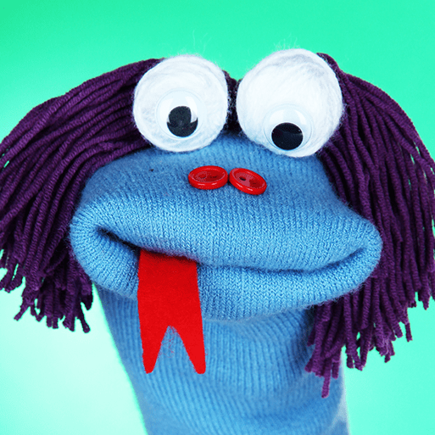  This creative project explores puppets and pop-up books. Your child will create puppets and use them to communicate with and tell stories. They will find out how puppets are used all over the world to tell stories. They will learn to join materials in different ways and find out how shadows are formed.
Cycle A; What are we learning about?

Spring 1 |  | Spring 2
Project | Companion Project | Project | Companion Project
Long Ago | Stories and Rhymes | Ready Steady Grow | Signs of Spring
This project teaches children about how they have grown and changed since they were babies and how life in the past was different from today. Your child will learn about their history and their family history and heritage and find out what life was like when their grandparents were children. They will learn about what it was like to go to school in the past and how everyday objects, such as clothes, toys and vehicles have changed. | 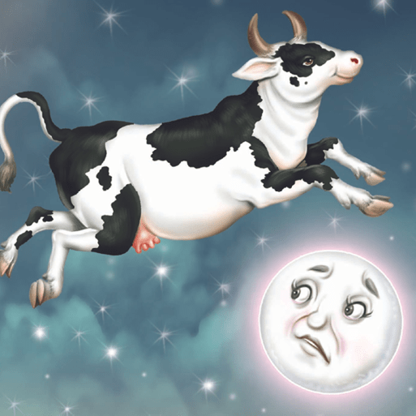In the Stories and Rhymes project your child will be introduced to the wonderful world of stories and nursery rhymes, give them the opportunity to play with words and learn new vocabulary. They will listen to and learn a range of traditional tales and nursery rhymes and work creatively to solve problems for the characters they meet. | 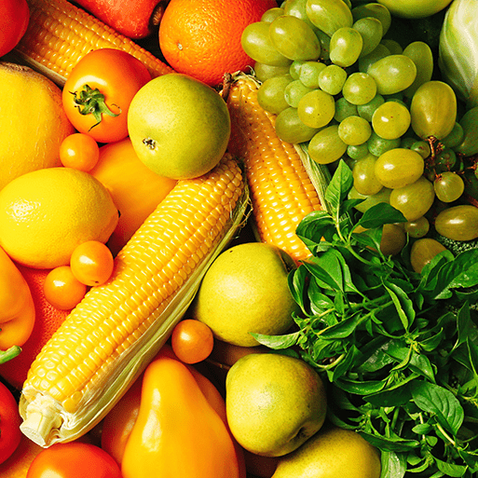  In the Ready Steady Grow project your child will take part in practical activities to explore where food comes from. They will learn what seeds and plants need to grow and grow a variety of plants. They will explore what constitutes a healthy lifestyle, including eating fruit and vegetables, exercise and teeth brushing. They will find out about life on a farm and about baby animals. | 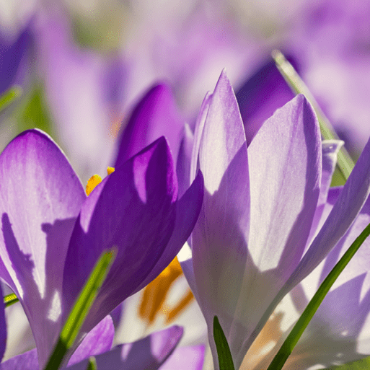  This project teaches children about the changes that happen during the spring, including weather and the festivals that are celebrated at this time of year.

Summer 1 |  | Summer 2
Project | Companion Project | Project | Companion Project
Animal Safari | Creep Crawl and Wriggle | On the Beach | Move It
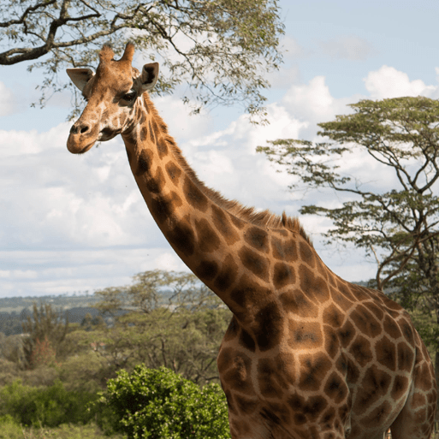  In the Animal Safari project, your child will learn about incredible animals that live worldwide. They will explore various animal habitats and compare the animals that live there with animals in their locality. They will learn how to care for pets and what all animals need to grow, survive and stay happy and healthy. They will explore animal features and find out how they survive in the wild. They will compare the ways that animals are similar and different. | 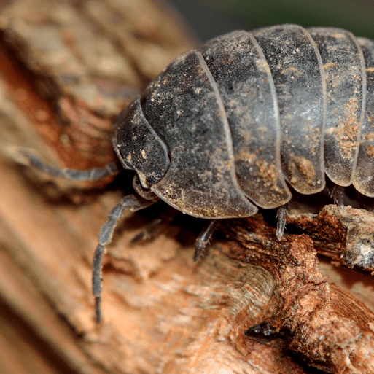  In this project, your child will learn about minibeasts. They will observe minibeasts in their natural habitats and create shelters for them to live in. They will learn about the life cycle of a butterfly and explore what minibeasts, such as snails and worms, need to survive. They will compare the features of minibeasts and learn the names of their body parts. | 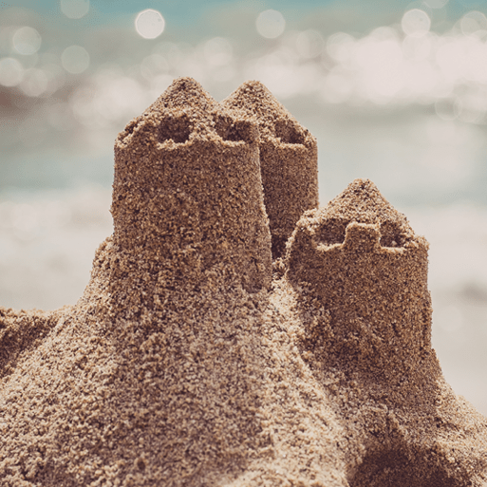  In this project, your child learns about animals that live in rock pools and on the seashore. They will explore days out at the beach and compare their experiences with beach holidays in the past. They will learn about the animals that live in the sea and find out about worldwide seas and oceans. They will explore the importance of looking after the environment to keep living things safe. They will learn about staying safe in the sun and find out about people who help us. | 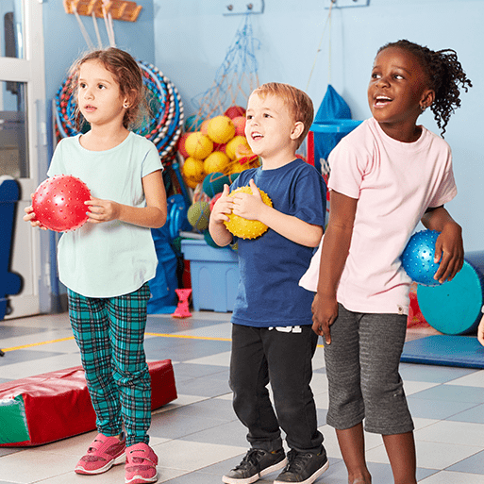  In the Move It project, your child will participate in physical activities and learn about the importance of exercise, getting a good night’s sleep and eating a healthy balanced diet. Aswell as explore outdoor, summer games and activities.

