

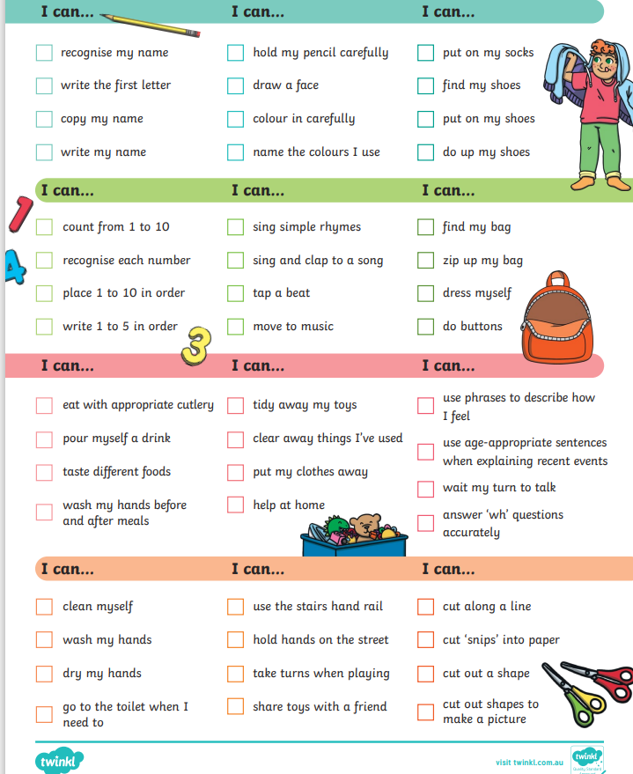
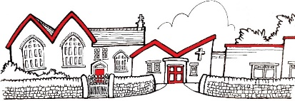
Things to remember…
- Once settled, Reception will be bringing home a reading book which will be changed M/W/F.
- Forest Fridays-Scruffy clothes, waterproof coat with hood and hat/gloves where appropriate, and named wellies (these will be kept in school)
- Our class library session will be Friday.
- PE will Friday PM therefore no PE kit is required as children will be in forest school clothing.
- £1 snack money per week, or in advance
- Bottles are not required as water is always accessible for children.
- Books bags are mandatory for Reception children, thus other bags are not needed.
- We do suggest having a spare set of clothes, to be kept in school, just in case.
Homework
In Early Years, the best way to support your child’s development is to spend time with them, having conversations, sharing books together and encouraging independence.

Remember, every child is different and there may be things you child can/cannot do which other children can, please do not worry.
However, if you do have any questions or concerns, my door is always open.
Welcome to St George’s EYFS.
I hope you’ve all had a lovely summer and enjoyed the bits of sunshine we have had!
It’s exciting to be back, catching up with familiar faces and creating new friendships.
EYFS News
What will we be learning?
Our project this term is ‘Let’s Explore’, where your child will explore their class environment and school grounds so that they feel settled and happy in their new surroundings. They will learn about the local environment and find out about places they have visited on holiday. They will look at and create maps for journeys.
In ‘Build It Up’, our companion project, your child will explore structures in the world around them. They will learn about materials and their properties and will have the chance to work independently and in groups to design and make marvellous structures.

