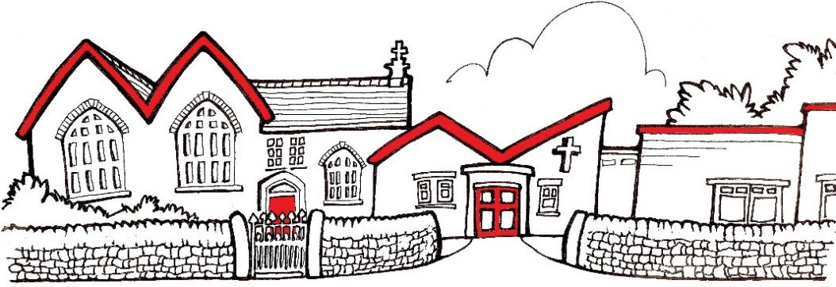


Church Lane,
New Mills,
High Peak.
SK22 4NP
01663 743222
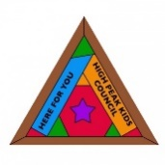



St George’s C of E Primary School
info@st-georgescofe.derbyshire.sch.uk www.st-georgescofe.co.uk

Mrs L Kilford Jen Rackstraw
Exec Headteacher Chair of Governors

Dear Parent or Carer
As you may have seen in the news recently, the number of measles cases is increasing across the country. Measles is a serious illness, with one in five children who get the disease having to be admitted to hospital for treatment, so if you or your child have not had your MMR jab, it is vital you contact your GP.
A new national NHS measles catch up campaign is being launched. This campaign will see all parents of children aged from six to 11 years contacted encouraging them to make an appointment with their child’s GP practice for their missed MMR vaccine.
NHS figures show more than 3.4 million children under the age of 16 years are unprotected and at risk of catching these serious and completely preventable diseases.
Having both measles, mumps and rubella (MMR) vaccinations is the best way of protecting your child, family and community from measles. The MMR vaccine is available for every faith. There is a type of MMR vaccine that does not contain pork gelatine (porcine), so it can be used for people who abstain from any pork products. This vaccine is available at every GP practice, and it is free. Please contact your GP to book an appointment for Measles (MMR) vaccine. Children and adults can catch up on any missed vaccines. MMR vaccination is given at one year of age, and at 3 years 4 months by your GP. Two doses of the MMR vaccine is the best protection against measles and can provide life-long immunity. Anyone unvaccinated who is exposed to someone with measles may be advised to isolate for 3 weeks. This would disrupt their learning or work and could happen repeatedly.
If you are unsure if your child has had both vaccinations, please call your GP to confirm or to book an appointment. Older children and adults who have not had two doses of MMR can also ask their GP surgery for a vaccination appointment.


The initial symptoms of measles:
- Resemble a cold with runny or blocked nose, cough and a slight fever
- Eyes become red, sore, watery and sensitive to light
- Sneezing
As the illness progresses, children may develop:
- A high fever
- A raised red rash that usually begins on the face and spreads downwards to the neck, trunk, arms, legs and feet
- Small white spots inside the cheeks and lips
For some people, measles can be very serious if it spreads to other parts of the body, such as the lungs and the brain. Problems can include pneumonia, meningitis and seizures (fits). If you think your child may have measles:
- Call your GP or NHS111 – do not attend your GP practice or any other healthcare setting (e.g. A&E) unless told to do so as measles spreads very easily.
- Avoid close contact with babies, pregnant women and anyone with a weakened immune system. These people are at increased risk of severe disease from measles.
- Stay off nursery, school or college for at least 4 days from when the rash appears.
Parents and carers can find out more about the different vaccines their child should have and when by visiting www.nhs.uk and searching for ‘NHS vaccinations and when to have them’.
Yours Sincerely

Mrs L Kilford
Executive Headteacher

