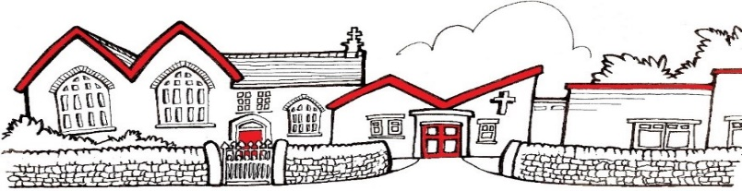

Dear Parent/Carer

Did you know that as well as free school meals during term time, you are also entitled to access FREE holiday clubs this spring?
The Holiday Activity and Food Programme, known throughout Derbyshire as ‘It’s About Me’ is funded by the Department for Education and gives eligible young people access to FREE places at holiday clubs across the county.
If your child is aged between 4-16 and is eligible for benefits-related free school meals, then they are entitled to access It’s About Me holiday clubs for free! There are a huge range of activities available including sports and games, arts and crafts, cookery, dance and music. All clubs include a nutritious meal too! Programmes vary depending on the type and location of each club.
If your child is not eligible for the It’s About Me programme, many clubs also offer paid places which you can book with them directly.
To book your holiday club you will need your unique IAM code which will be distributed via your child’s school. If you have not received your code, but believe your child is eligible for the programme, please contact your school office.
To book your activities and to find out more information go to www.itsaboutmederbyshire.co.uk or speak to your school office. To receive programme information and updates directly to your inbox, Sign-Up to It’s About Me updates.
The spring 2024 holiday clubs will take place from Tuesday 2nd to Friday 12th April. Excluding bank holidays and weekends. Bookings open on Monday 11th March.
Kind regards,

Mrs A Morley
St George’s C of E Primary School

