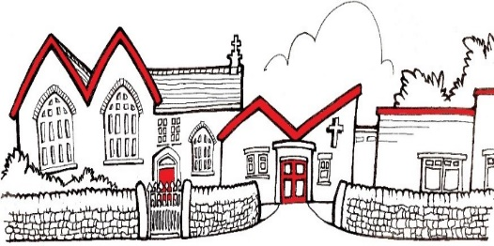
Replace this box with your school logo or delete before sending

Dear Parents / Carers,

Did you know that as well as free school meals during term time, you are also entitled to access FREE holiday clubs this summer?
The Holiday Activity and Food Programme, known throughout Derbyshire as ‘It’s About Me’ is funded by the Department for Education and gives eligible young people access to FREE places at holiday clubs across the county.
If your child is aged between 4-16 and is eligible for benefits-related free school meals, then they are entitled to access It’s About Me holiday clubs for free! There are a huge range of activities available including sports and games, arts and crafts, cookery, dance and music. All clubs include a nutritious meal too! Programmes vary depending on the type and location of each club.
If your child is not eligible for the It’s About Me programme, many clubs also offer paid places where you can book with them directly.
To book your It’s About Me holiday club you will need your unique IAM code which will be distributed via your child’s school. If you have not received your code, but believe your child is eligible for the programme, please contact your school office on
info@st-georgescofe.derbyshire.sch.uk
To book your activities and to find out more information go to www.itsaboutmederbyshire.co.uk or speak to your school office. To receive programme information and updates directly to your inbox, Sign-Up for It’s About Me updates.
The winter holiday clubs will take place from Monday 23 December – Friday 3 January. Excludes Bank Holidays and weekends. Bookings open on Monday 2 December 2024.
Kind regards,

Mrs S. Craig
Executive Head Teacher

