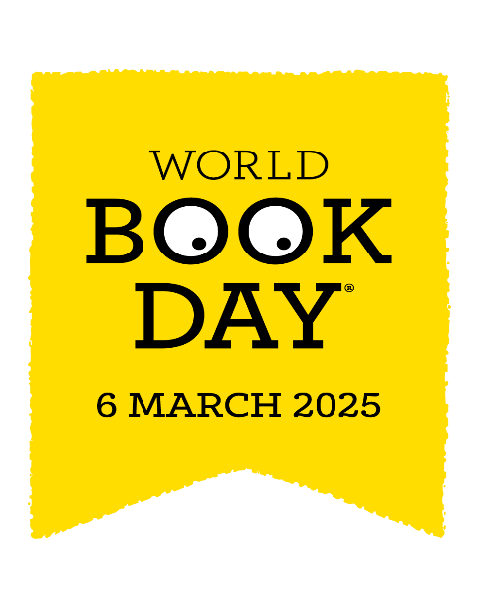
Dear parents, carers and pupils,
We are very excited to celebrate World Book Day this year with you all. In this letter you will find news of all the activities we will experience on the day and the competition to have a go at in preparation for it.
ACTIVITIES- To begin the day we are asking parents to join their child in class to share a story and a craft activity (9AM-9:45am). During the day there will be more fun booky activities including a story trail.
COMPETITION- Children are invited to recreate a scene from their favourite story, inside a box (shoe box/cereal box etc). They will be given the opportunity to use their box to retell the story to their classmates during World Book Week. For inspiration, please see the pictures below for examples of stories in boxes. Please note, this is an optional activity. The boxes should be brought to school by Wednesday 5th March. Good luck, there are lots of prizes to be won.
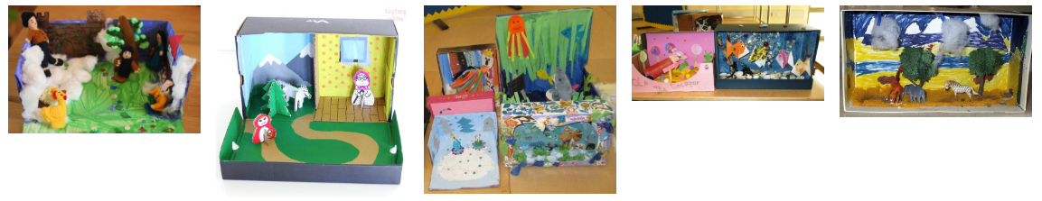

COSTUMES- On World Book Day this year we are inviting everyone to come to school dressed as a character from a book. This can be a character of your own choice and it would be fabulous if you could bring the book in too.
Please talk to your class teacher if you need any tips or inspiration. In assembly on the day we will have a parade around the hall to share our costumes.
Happy Reading!
Mrs Hall

