Dear Parents and Carers

We are delighted to announce that on Friday 16th May 2025 we will be visited by Philip Kavvadias, award-winning author of MISSION MICRORAPTOR and MISSION MANTA RAY.

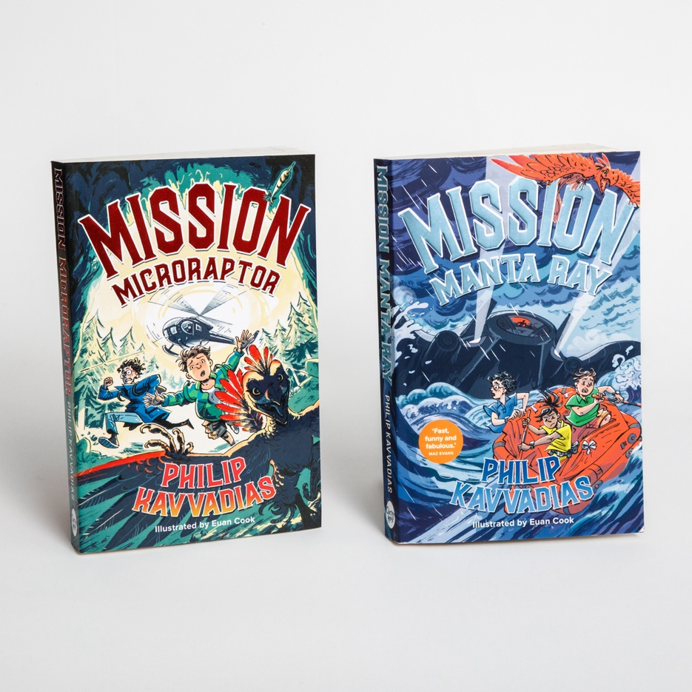

Philip is an Engineer, Scout Leader and Sustainability expert for one of the most recognisable brands in the world. His books (the third of the trilogy coming out later in 2025) are big adventures, with humour, lightning action, powerful villains and state-of-the-art technology. Philip is visiting schools all over the country, creating huge enthusiasm among children and inspiring them to fall in love with books and reading.

You can order copies of Philip’s first two books through Parent Pay. We are very fortunate to have been offered a 50% discount, which means you can buy each copy at only £4, in other words two for the price of one! Orders close at Monday 28th April.

Many thanks for continuing to support your children’s reading.

All the best,
Fiona Hall

