Dear Parents and Carers

As you know we have recently been visited by Philip Kavvadias, award-winning author of MISSION MICRORAPTOR and MISSION MANTA RAY.

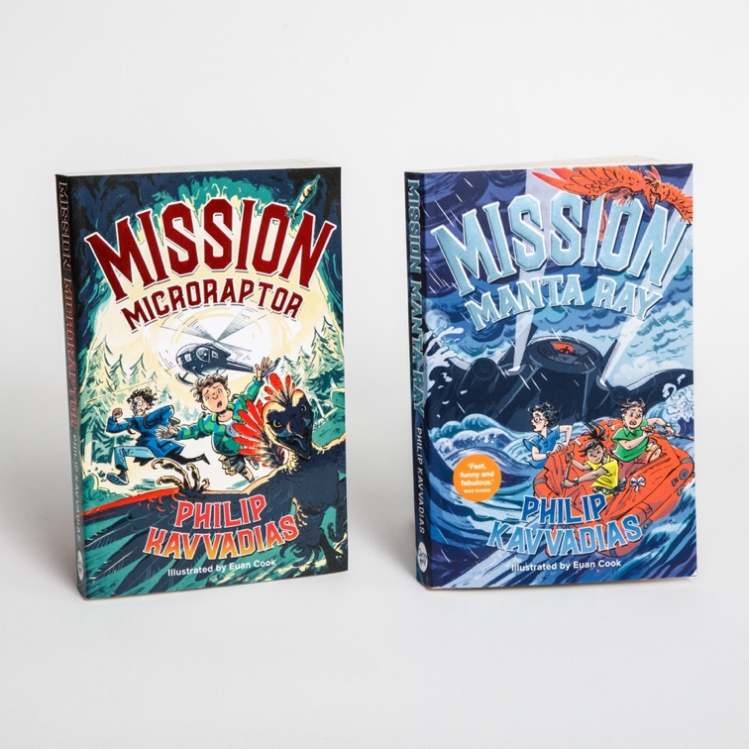

Philip is an Engineer, Scout Leader and Sustainability expert for one of the most recognisable brands in the world. His books (the third of the trilogy coming out on 3rd July) are big adventures, with humour, lightning action, powerful villains and state-of-the-art technology. Philip is visiting schools all over the country, creating huge enthusiasm among children and inspiring them to fall in love with books and reading.

You can order signed copies of Philip’s first two books using this link:

https://philipkavvadias.com/products/microraptor-gift-bundle

Philip was kind enough to offer his visit to us free of charge and he has asked if the parents of kids who have already read his books could leave reviews here:

Mission Manta Ray https://amzn.eu/d/e99FIMY

Mission Microraptor https://amzn.eu/d/ji6SeVo

If you could, it would be a very nice thing to leave a review for Philip as he is a new author who needs our support.

All the best,
Fiona Hall

