
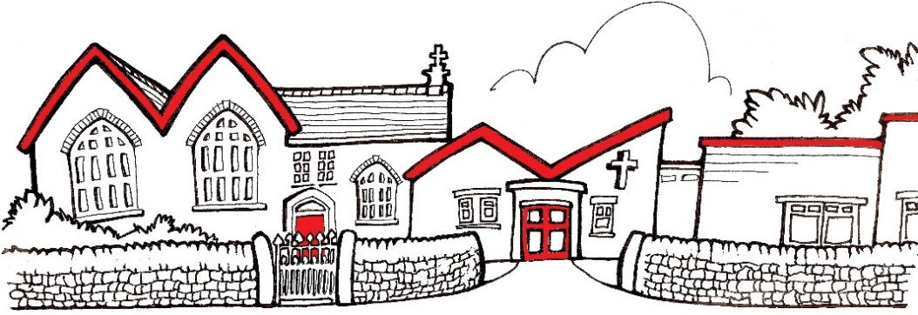
Church Lane,
New Mills,
High Peak.
SK22 4NP
01663 743222

St George’s C of E Primary School
info@st-georgescofe.derbyshire.sch.uk www.st-georgescofe.co.uk
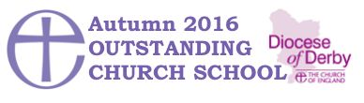
Mrs. S Craig Mrs. J Rackstraw
Exec Headteacher Chair of Governors
22.11.2024

Dear Parents / Carers,

We are delighted to announce that we are planning a school trip for Y3/4 and Y5/6 to The Bridgewater Hall on Tuesday 4th March 2025. They will be experiencing a live concert by the Halle orchestra.

We expect to leave school at approximately 9 am and arrive back to school at approximately 1 pm, in time for your child to have their lunch in school. Pick up will be as normal from school at 3.15pm

The whole trip including the coach will cost £8.70 per child, this can be paid via Parent Pay. If we receive insufficient voluntary contributions the trip may have to be cancelled. However, if you are experiencing financial difficulty and are unable to afford this trip, please speak to Mrs Morley in the office.

The children will need a packed lunch (including a drink) on the day (no glass bottles and healthy options please). If your child is entitled to a free school meal we can provide them with a free packed lunch, please indicate on the form if your child would like one. We will all have lunch when we return to school.

Your child will need to wear their school uniform and bring a waterproof coat. Your child will NOT need to bring any spending money. For the performance, please send your child with a water bottle and a snack.

If you would like your child to take part in this trip, please fill out the form below and return it to school as soon as possible. Payment for the trip must be made by Monday 16th December.

Kind Regards,
Mrs. Hall, Mrs. Redfearn and Mrs. Craig

I would like my child ……………………………………………………………………………………………………………………………………..
to take part in the trip to the Bridgewater Hall on Tuesday 4th March 2025.

Signed………………………………………………………………………………………………………………parent / carer

My child is entitled to free school meals and would like a free school packed lunch on this day. (please tick box).

I will make my payment on Parent Pay by Monday 16th December.

