Female composers Friday assemblies
1-https://www.bbc.co.uk/teach/ten-pieces/articles/ztsb7v4
Laura Shigihara - Grasswalk from Plants vs. Zombies
2- https://www.bbc.co.uk/teach/ten-pieces/articles/zhyyb82
Anna Meredith - Connect It
3- https://www.bbc.co.uk/teach/ten-pieces/articles/z2tfdnb
Reena Esmail - Sun Sundar Sargam
4- https://www.bbc.co.uk/teach/ten-pieces/articles/zs6nkhv
Margaret Bonds - March and Dawn from Montgomery Variations
5- https://www.bbc.co.uk/teach/ten-pieces/articles/zxpvjfr
Cassie Kinoshi - the colour of all things constant

Laura Shigihara

Cassie Kinoshi

Reena Esmail
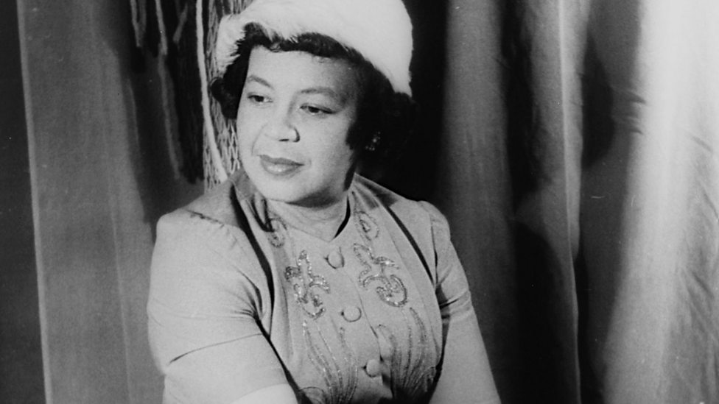
Margaret Bonds

Anna Meredith

