St George’s Church of England Primary School

Nursery Parents’ Handbook

Nursery Prospectus

2023-2024

St George’s C of E Primary School
Church Lane
New Mills
SK22 4NP
01663 743 222
info@st-georgescofe.derbyshire.sch.uk
www.st-georgescofe.co.uk
Welcome to St George’s Church of England Primary School and Nursery

We very much hope that you and your child will enjoy your time at our nursery.

When children enter our nursery it could be the first time they have separated from the comfort and secure zone of their parents. Therefore, we aim to create a warm, nurturing, fun and happy environment which is like a second home. In our nursery your child will feel comfortable to explore, and it is through exploring that your child will learn.

Your child is at a crucial stage in their development with research showing that children learn more rapidly in the first seven years of life than at any other time. It is therefore important that the children are given every opportunity to fulfil their potential. As a parent you play a very important role. The Nursery Team hope to play their part by offering your child a variety of experiences and activities designed to further their individual development.

We hope that your child discovers that learning can be an enjoyable and worthwhile process.

This Prospectus is intended to give you information about the nursery but please do not hesitate to contact us if you have any queries or concerns.

More information about our School can be found on our school website.

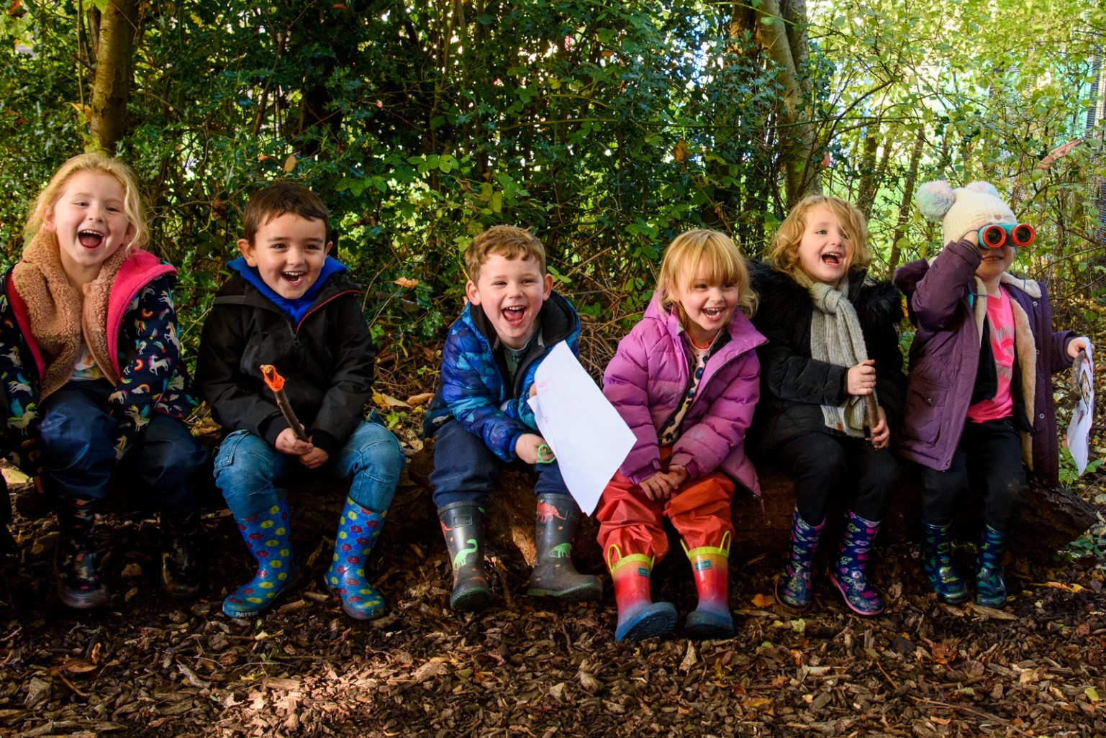

St George’s Church of England School and Nursery

Aims to:

- Create a happy, safe, caring and stimulating environment in which every child will feel valued, happy, secure and eager to learn.

- To assure the quality of teaching and provide an appropriate Foundation Stage curriculum which supports the social, emotional, moral, intellectual, creative and physical development of the ‘whole’ child.

- Encourage independence and confidence through opportunities to learn through play both indoor and outside.

- Enable every child to reach their full potential in all areas of learning, by recognizing that every child is unique.

- To help children understand and follow the school’s Golden Rules.

- To foster a sense of community by working with parents to build effective relationships based on respect and trust.

- To help children develop respect and tolerance for all cultures within our society so they begin to understand the world in which they live.

Our School Team 2023-2024
Nursery team are in red

Teaching Staff  Mrs Sarah Craig - Executive Headteacher  SENCO  Mrs F Hall – Head of School  Miss L Dawson – EYFS Teacher  Mrs V Calvert / Mrs C Tiffany – Teacher Y1/2  Mrs F Hall – KS2 Teacher Y3/4  Support Staff  Mrs A Stanton  Mrs J Shuker  Mrs H Swindells  Mrs K Kelly  Mrs E Percival  Mrs J Pelham  Miss L Andrew  Mrs C Tiffany  Mrs L Branch  Ms S Martland | Admin  Mrs S Webster - School Business Manager  Mrs A Morley – School Business Officer  Site Supervisor  Mr M Stanton  Site Handyman  Mr J Stanton  Midday Supervisors  Mrs M Bradbury  Mrs M Broadhurst  Ms S Martland  Cleaners  Mrs G Mycock  Mrs M Bradbury  Catering Staff (DCC)  Mrs E Lomas – Cook in Charge  Mrs L Jenkins – Kitchen Assistant

This is our current staffing structure, but this may change as and when numbers require.

Sessions

We offer full or half day sessions to suit you and your child’s needs. Our session times are as follows:

- Morning Session: 8.45am – 11.45am

- Full Day Session: 8.45am – 3.15pm

We do offer full days supporting the 30 hours free childcare initiative for working parents.
Which is 6 hours of funded education plus half an hour lunch. If your child is staying with us all day, please provide them with a healthy packed lunch or you can pay for a dinner in school.
To check your eligibility for free childcare, please visit – www.childcarechoices.gov.uk
Once you have your eligibility code, please bring it to the school office and we will secure your place. If you need anything further or have any questions then please contact Mrs Morley on 01663 743 222

- School lunches are freshly cooked on the site in the school kitchen.

- Details of school lunches and a copy of the menu is available to view on the school website.

Nursery Provision

Our nursery has excellent provision both indoors and outdoors.

Inside we have two rooms with a range of provision designed:

Creative area – including painting, drawing, colouring, sticking, model making

Construction area – including various construction toys, large and small wooden blocks, wooden train track

Small world area – including people, vehicles, wild animals, farm animals

Sand and water area – with a wide range of self-selection sand and water toys

Malleable table – with access to a variety of modelling tools

Music area – including different percussion instruments

Book area – with a selection of fiction and non-fiction books appealing to all interests

Mark Making area – including a variety of different mark making tools and a selection of paper, cards and envelopes

Large scale role play – with a fully equipped home corner and a selection of dressing up costumes.

Woodland area – which we use on Fridays

Our outside area – provides opportunities to develop children’s gross motor control and broaden their knowledge of the natural environment. Children are encouraged to explore, discover and problem solve to extend their learning

General outdoors provision includes:

Sand Water Bikes Outdoor

Large construction Mud kitchen House Climbing apparatus

Space to run and jump

The Foundation Stage of Learning

The Nursery and Reception classes are referred to as the Foundation Stage of learning. This is an important stage, as it is during this time that attitudes to learning are formed and social skills developed which lay the foundations for future education.

Young children learn most effectively through a balance of structured and child initiated play. We work together as team to plan for children’s learning in seven areas to ensure that all areas of development are covered within an interesting, stimulating and supportive framework. We also ensure that children progressively develop their skills and knowledge throughout this phase of their school life. The children are taught directly and also have a choice of planned activities so that they are able to develop independent learning habits.

The seven areas of learning and development are:

Prime Areas
- Communication & Language
- Physical Development
- Personal, Social and Emotional Development

Specific Areas
- Literacy
- Mathematics
- Understanding of the World
- Expressive Arts and Design

Partnerships with Parents

As parents you are the first educators of your children. We believe in a close partnership between parents and staff as we join you in educating your child.

We want to work closely with you. Good communication between staff and parents enables us to inform each other of relevant matters concerning your child. We appreciate being informed of any change at home that might affect your child and will treat anything you tell us in strict confidence.

At the start and end of each session there is an opportunity to briefly chat to the nursery team staff about your child. Parents’ evenings are held twice a year which are a ten-minute consultation with a member of the nursery staff to discuss your child’s progress, learning and development. We will inform you about the activities and learning situations that your child has experienced.

General Information

Registration & Morning Routine

The children have a designated peg (which they are able to identify with a picture) where they can keep their coats and bag. These pegs are designed to be at a height which is accessible for the children and we encourage them to be independent in finding their peg and hanging their things upon it.

Your Child’s Learning Journey

During their time in nursery the children will be constantly developing and learning new skills. We keep records of significant moments in their learning by creating a learning journey. This is really useful to us as there are very often things your child will do/say at home which we never get the opportunity to hear/see in nursery.

Sickness and Absence

We ask that you let us know when your child is absent due to illness, especially if they have an infectious illness. If your child has sickness/diarrhea, 48 hours must elapse before returning to Nursery.

To ensure children’s safety and help us meet Government guidelines, we request that parents contact us, whenever possible, by 9.15am to inform us of their child’s absence. In cases where parents have been unable to do so, we endeavor to contact parents ourselves.

Snack Time

We provide milk, fruit and other healthy snacks for a small fee each term for the children to drink and eat during the Nursery session. To encourage independence, we ask children to organise their own snack time routine which involves selecting their own choice of snack and tidying away their dirty pots when they are finished. Please advise us as soon as possible if your child has any food allergies or special dietary needs.

Toilets

We understand that not all children will be totally toilet trained when they start with us. We will happily work with you to help in any way we can during the toilet training process. ‘Accidents’ are not a problem but all we ask is that you supply spare clothing so that we can easily change your child if needed. If your child is still using nappies/pull-ups we can change these during the session/day but again we do ask that you supply us with nappies/wipes/nappy bags etc.

School Uniform/Dress

Please ensure that you choose clothes that are easy for your child to manage by themselves. Many of our nursery children will wear navy jogging bottoms or leggings and our school polo shirt and jumper. Velcro shoes are also advised. Please see our website for our school uniform policy. Please spend time before your child starts Nursery helping them to learn to put on, take off and fasten their own clothes and shoes. All clothing must be named clearly with a black pen or name labels.

Please note that nursery children do not need any PE kit but they will need suitable warm outdoor clothing and wellies for Forest School which will be discussed when they start nursery.

Medication

If a child is unwell they should not be sent to Nursery.

Parents are responsible for the administration of medicines to their child. Selected staff are available to administer certain medicines upon the completion of a form and by prior arrangement.

If a doctor advises that a child should attend Nursery while still needing to take medicine, the parents need to inform the Nursery and complete the appropriate form for the medication to be administered.

If your child suffers with asthma, parents must complete the relevant form and ensure their child always has an inhaler in Nursery.

Please see Mrs Morley on reception for any medical forms

Sun Safety

Please help us to ensure that your child is protected in the sun whilst in our care by providing sunhats, water bottles and sun cream. We do ask that parents apply creams before Nursery. It is imperative that every child in Nursery has access to quality sunscreen, for this reason if a child is found to be in need of sun protection, for full-time children nursery staff will apply sunscreen from their own supplies, unless you inform us otherwise.

Permission for photographs, walks in our area

By law we need permission from parents and carers to photograph your child and take them away from the school site. When you join the nursery, we will ask you to sign a consent form which will allow you to tell us if we may photograph your child and how photographs of your child can be used. There will also be a form to give us permission to take your child on short walks in the local area.

Special Educational Needs and Disability & Equal Opportunities

Our Nursery will promote self-confidence and a positive attitude to learning in all children whatever their gender, ethnicity, home language, special educational needs, disability or ability.

Our school SENDCO (special education needs and disability co-ordinator) is:

Mrs Sarah Craig (Head of School)

If you have any concern regarding your child, please discuss this with the class teacher or Mrs Craig.

The following forms need to be filled in and handed to the office before your child starts nursery school.

Please also provide us with a copy of your child’s birth certificate.

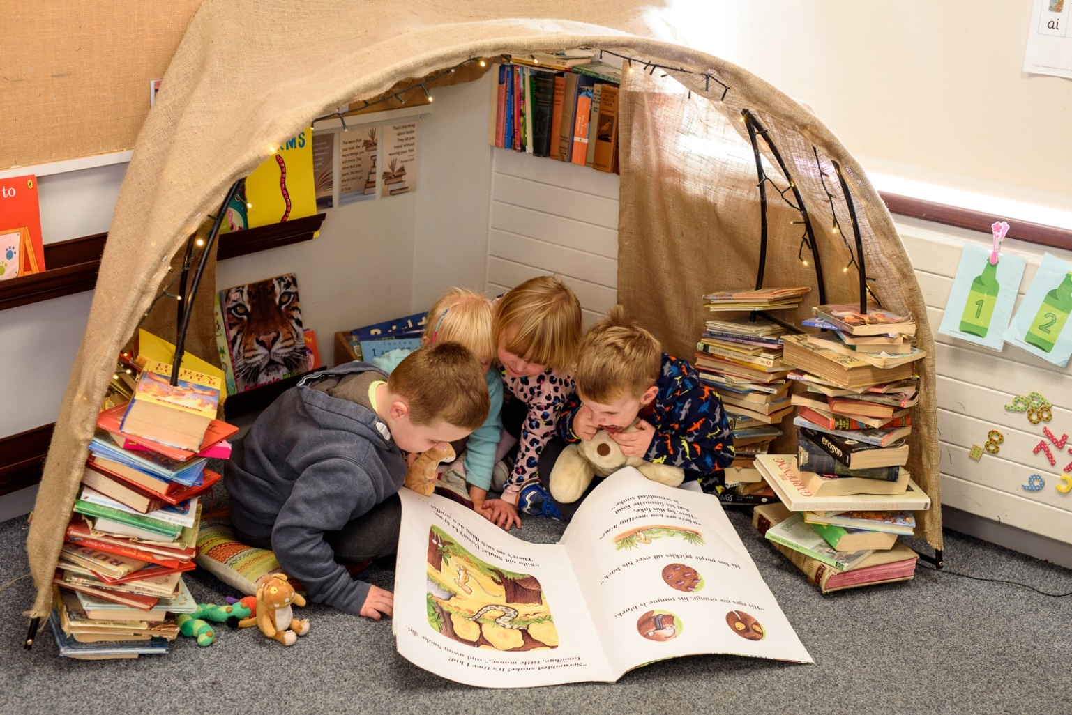

Pupil Information Form
Data Protection Act 2018 – The School is collecting this data in order to meet its statutory responsibilities for the provision of education to children in accordance with the requirements of the Education Act 1976 and The School Standards and Framework Act 1998. Some of this data will be shared with the Local Authority and may be shared with other agencies that are involved in the health and welfare of school children, at the discretion of the school and subject to agreement by parents/carers.
First Name

Preferred First Name
Legal
Surname:
Date of Birth |  | Gender –  Male |  | Female
Names of any brothers/sisters already at this school
Pupil’s home address

Postcode
Previous School,
Nursery or child minder

Medical Details
Doctor’s Name |  |  | Doctor’s Tel. No.
Doctor’s Address

Please provide details of any medical conditions that the school should be aware of, and any emergency action that should be taken (e.g. Asthma, Epilepsy, Allergies to bee stings, nuts or particular medicines.

Emergency Contact Details
We must be able to contact the people detailed below during the school day.
The person named in Priority 1 below should be the only person we need to contact in the vast majority of cases since they should be available and based locally.
Please make the people named below aware that you have nominated them.

Priority | Title | First Name | Surname | Gender | Relationship to child | Parental Responsibility
1 |  |  |  |  |  | Yes/No
Address:  Post Code: |  |  |  |  | Email:
Home Phone |  |  | Mobile | Work Phone

Priority | Title | First Name | Surname | Gender | Relationship to child | Parental Responsibility
2 |  |  |  |  |  | Yes/No
Address:  Post Code: |  |  |  |  | Email:
Home Phone |  |  | Mobile | Work Phone

Priority | Title | First Name | Surname | Gender | Relationship to child | Parental Responsibility
3 |  |  |  |  |  | Yes/No
Address:  Post Code: |  |  |  |  | Email:
Home Phone |  |  | Mobile | Work Phone

Priority | Title | First Name | Surname | Gender |  | Relationship to child | Parental Responsibility
4 |  |  |  |  |  |  | Yes/No
Address:  Post Code: |  |  |  |  |  | Email:
Home Phone |  |  | Mobile |  | Work Phone

Collecting your child from school

Regarding the release of your child(ren) at the end of the school day.

Who will be the person who usually picks up your child(ren)?

Name (s)…………………………………………………………………………….

Relationship to child ………………………………………………………….

Contact tel. no. …………………………………………………………………

If the person above will not be picking up your child(ren) on a given day, you need to inform school who this will be. If you know who this is please give details below:

Name …………………………………………………………………………….

Relationship to child ………………………………………………………….

Contact tel. no. …………………………………………………………………

Important

If anyone different is collecting your child from school, you must telephone school to let us know who this will be before the end of the school day.

Court orders

Is there a Court order against any person who is not to have contact with your child? If so, we do need you to bring the documentation into school so that we can act accordingly.

Please detail any court orders applied to your child below (e.g. Ward of Court, Legal rights etc)

Does your child have a parent currently serving in the UK military? Please provide details below


Application for Pupil Premium Funding/FSM

We are asking all parents and guardians of children who will be attending a Derbyshire school in any class including Nursery Classes (aged 3 or 4 years old) to complete and return the form below. We will then be able to confirm whether the school is entitled to claim the Pupil Premium for your child. The Pupil Premium provides extra funding within the school for additional equipment and support. Please complete all sections of this form and return it to your school for processing in accordance with the Data Protection Act 1998 and the Council’s Information Management policy.

Name of School | St Georges C of E Primary School

Please provide of your child and all other children in your family, below.

Child’s Surname | Child’s First Name | Date of  Birth | Name of School Attended

Please provide Parent/Guardian Details (this information is required by HMRC to process the Pupil Premium funding)

Surname | First Name | Date of Birth | National Insurance No | Telephone Number

The information I have given on this form is complete and accurate. I will notify Derbyshire County Council of any change in circumstance during the school life of my child/ren whilst attending schools in Derbyshire. I agree that Derbyshire County Council can use the information I have provided for the purpose of collating information and making the application for Pupil Premium Funding.
Signature of parent/guardian: ……………………………………………………………………………………………………
Parental Consent Form

Forename:
Surname:
Date of Birth:

Please give each statement your consideration and complete the form as appropriate by circling the appropriate answer; Parental consent to Data Processing must be obtained for pupils younger that 13 years of age.

Photo Permission
There are many activities and occasions in school where children are likely to be photographed to record their achievements and successes and to complement work they do. As a parent / carer you have the right to decide whether you wish to give consent to your child’s image being captured during such an activity. We may use photographs in our school publications or on our display boards in school.
I give permission for my child to be photographed during an activity as described above.

Yes No

Individual Photo Permission
Children have photographs taken individually and within a class group on an annual basis by the schools chosen photographer. We require parental consent to authorise photographs to comply with data protection and GPDR regulations as the photographer will need basic information about your child. Parental consent must be obtained for any child under the age of 13 and if you do not wish your child to be photographed for their class photographed, please make us aware.
I therefore give permission for my child to have their annual school photographs.

Yes No

Website
The school may post Images to the school website or any brochures relating to the school which may require pictures although no name will be used to identify a child.
I give permission for my child’s photograph to be used on the school website or in a schools brochure.

Yes No

Outside Media
From time to time, our school may be visited by the media or other invited agents who may take photographs / film footage or carry out newspaper / radio / television interviews and names of the children may be mentioned in their publications.
I give permission for my child’s photograph / film to be used by the media and for my childs name to be released for publication such that my child may be identified as an individual or as part of a small group.

Yes No

School Events
Whenever there are events to which we invite parents and other family members we will allow photographs / video footage to be taken but we ask everyone to not post any images they have captured on the internet and social media.
I agree that any photograph or video I take at a school event will be for personal or family use and will not be out on the internet.

Yes No

Classroom and Internal School Displays
We use your child’s first name on displays in school to identify their work and help your child to identify their name.
I give permission for my child’s first name to be used on internal school displays

Yes No

PG & U Classification films
At various times throughout the year we would like to be able to show either to further enhance the curriculum or as a trat. The films are either suitable for all ages or PG. We would like your permission to allow your child to watch a PG film.
I give my permission for my child to watch a PG film in school

Yes No

Local Walks
The school offers opportunities during the year for our pupils to take part in a variety of activities in the immediate locality. We are seeking a single permission to enable children to take part. All activities will be detailed in the school newsletter or by text or by letter to affected parents, there will be no cost to parent’s and they will take place during the school day. These could include fully supervised local environmental walks or visits to church.
I give permission for my child to undertake supervised activities within the local area

Yes No

Internet Access
Your child may be required to access the internet when having ICT lessons. I give permission for my child to access the internet at school.

Yes No

Outside Providers
We also pass information on to the following companies for the reasons listed. Please indicate your consent by ticking the relevant box to enable us to share this information. For more information on the companies GPDR compliance, please look at the company website or contact the school office.

Yes No

Pearson education – Power Maths
https:www.pearson.com/uk/pearson-privacy-and-you/privacy-policy.html
To access learning resources and homework using a password. We need to provide and keep your child’s name, date of birth, year group and class name. This information will change each year as they move through school. I give my permission for my child’s personal information to be used for the purpose as described above.

Yes No

Cornerstones
http://cornerstoneseducation.co.uk
To record pupil progress and attainment. We need to provide pupil name, date of birth and assessment data in order to receive an accurate picture of your child’s progress in literacy / Math’s and other curriculum areas e.g Science. I give permission for my child’s personal information to be used for the purpose as described above

Yes No

School Leavers Company
http://www.schoolleaverscompany.co.uk
To order Year 6 leavers hoodies we need to provide your child’s name and class name.
I give permission for my child’s personal information to be used for the purpose as described above at the applicable time.

Yes No

TheSchoolApp
To receive text messages from a school regarding events, reminders and other information such as newsletters. We need to provide your child’s name and class name, year group and your mobile number and email address. I give permission for my child’s personal information to be used for the purpose as described above

Yes No

Parent Pay
This allows you to make fast and secure payments from your bank account directly to school for dinner money, breakfast club, after school club and trips! We need to provide your child’s full name and class / year group. I give permission for my child’s personal information to be used for these purposes.
Yes No

Your right to withdraw consent:
Please note that you have the right to withdraw these consents at any time and you can do this by contacting us at the address given below:

For more information on how St Georges C of E Primary School uses data we hold about you, how long we keep it and your rights relating to it, e.g to have it corrected, erased, restricted, transferred or to see your records go to our website at www.st-georgescofe.co.uk or contact Mrs Morley at the school on info@st-georgescofe.derbyshire.sch.uk or 01663 743 222 or in writing to

St Georges C of E Primary School
Church Lane
New Mills
High Peak
SK22 4NP

Your choices will be applied for the duration of your child’s time at St Georges C of E Primary School unless you tell us otherwise in writing.

SIGNED:
PRINT NAME:
RELATIONSHIP TO CHILD:
DATE:

St Georges C of E Primary School Pre-Entry Information

At home
My full name is
I am known as
At home I live with

I am the; (please circle) only child, oldest child, middle child, youngest child
Relationships with other agencies
Is my family registered at a Children’s Centre?
Have I already had support from (please circle) Health visitors, Family Support Workers, Social Care, Speech and Language Therapists Etc?

Are there any concerns about my hearing? Date of last hearing test
Early Education and Experiences
Did I attend any Children’s Centre sessions?
Did I attend any other parent and toddler play groups?
Did I attend a Nursery, have a child minder or other?

Development Milestones
Did I have a dummy/ comforter? Y/N
Do I still have a dummy /comforter? Y/N
What age did I start to walk?
What age did I start to talk?
What is my speech like now?
Can I feed myself? Y/N Can I use a cup without a lid by myself? Y/N
What is my sleeping pattern like? Do I have a bedtime routine?

Can I use the toilet independently and wash my hands?
Do I need reminding to go to the toilet?
Do I wear a nappy in the day time? Y/N At night time? Y/N
What can I do now?

 |  |  | Yes | No | Some  times
Do I enjoy playing with other children?
Do I look at books and listen to stories with interest?
Do I show interest in numbers, colours and shapes?
Do I know any songs or rhymes?
Do I experiment with mark making using crayon, pens or paint?
Can I focus and concentrate for several minutes on something that really interests me?
Show care and concern for others?
Do I engage in imaginative role play or pretend play?
Can I put on my own shoes?
Can I put on some of my own clothes for example, my coat or pants or trousers?
Can I recognise my own name?
 | Mums, Dads and Carers
What do you want for your child while they are at St Georges Nursery?
Notes…..

